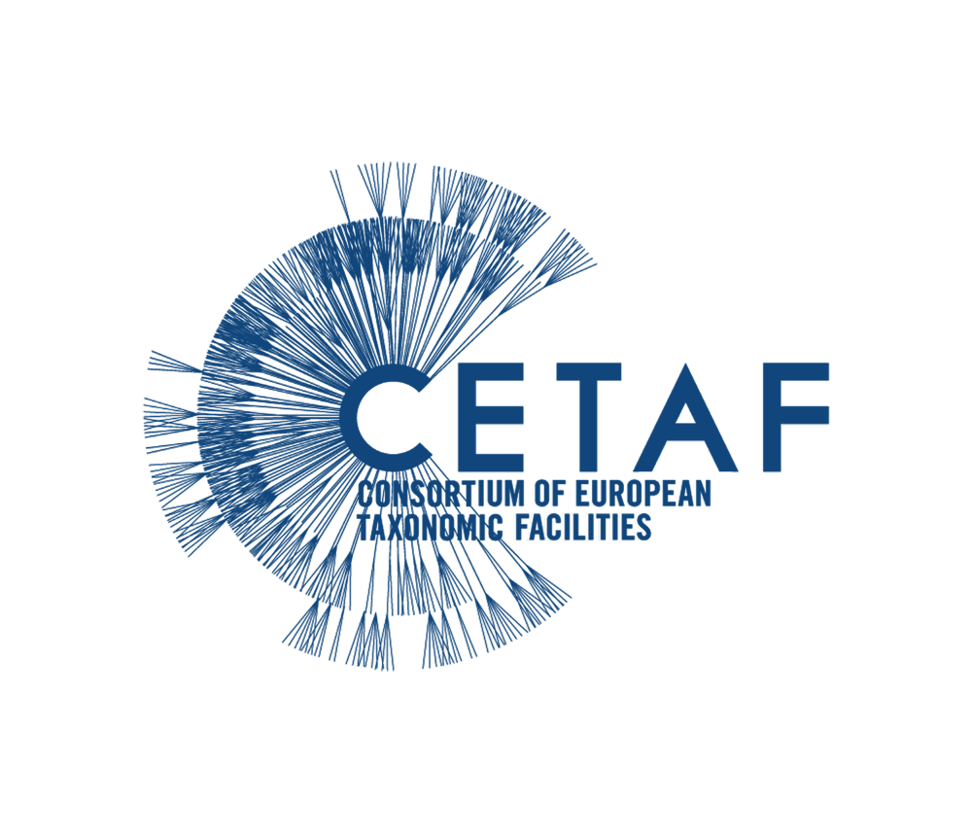

The CETAF General Secretariat is currently looking for a new Training and Expertise Officer to join its team in Brussels!

As **Training and Expertise Officer (m/f/x)**, you will be joining our team at the General Secretariat in Brussels and will be in charge of coordinating CETAF’s role in EU projects and internal initiatives with training-related tasks. You will be supervised by and work closely with the Executive Director, as well as in collaboration with the other General Secretariat Staff.

**Who are we?**

The CETAF community unites major natural history and natural science museums, botanic gardens and research centres in Europe to create a unique research network made up by 40 Members including 70 research organizations across 22 countries.

The collections at the heart of CETAF Members facilitate fundamental geodiversity and biodiversity research, particularly in taxonomy and systematics, that enables ground-breaking discoveries across broad fields of science. The CETAF community jointly holds 1.5 billion specimens that represent about 80% of the world’s described species. These institutions and their researchers are custodians of this irreplaceable natural heritage that serves scientific and social progress.

**Key Responsibilities:**

* Development of a training schema for a European-wide Research Infrastructure (DiSSCo.eu) through an evidence-based approach of user needs analysis, identification of existing training modules, definition of key components and production of outcomes in the form of recommendations for the further development of a training strategy;
* Coordination of CETAF’s contribution as partner on the Horizon2020 project BiCIKL with tasks mainly focused on the development of an educational cloud (MOOC) with technical training guidelines and documentation.
* Supporting the organization, development and promoting the usage of DEST, the Distributed European School of Taxonomy (cetaf.org/dest)
* Support the organization of meetings and events related to capacity building, as well as others relating to the general objectives of CETAF (general assembly, etc.)
* Contribute to set-up the CETAF Registry of experts;
* Other technical activities necessary for the good functioning of the General Secretariat of CETAF and the achievement of the organisation’s objectives

**Position Requirements:**

* Good knowledge of the EU structures and understanding of EU-funded projects on the field of research, science and biodiversity, specifically Horizon2020;
* Proven organisational. coordination and project implementation skills, including report writing;
* Experience in the development of a tailored models for training;
* Experience in the development and implementation of web-based training programs (eg. MOOC), and in the use of training platforms (as Moodle);
* Capable of processing complex information received from stakeholders in the field of biodiversity and translating their needs into training programmes;
* Able to conduct user needs analysis and identification of gaps in training and capacity building;
* Experience in organisation of workshops, roundtables, webinars and events for stakeholder consultation processes in training-related topics;
* Ability to communicate and work with distributed teams and with different partners and stakeholders across countries and disciplines;
* Good written and verbal communication in English;
* Proactive and well organized, with the ability to work independently (and remotely when necessary);
* Use of Office Suite (Outlook, Word, Excel, Powerpoint), collaborative tools such as Google Drive, and online training tools.

**Desirable experience/skills:**

* University degree (Master’s degree or equivalent Bachelor with working experience) in sciences or biodiversity-related fields
* Familiarity with membership-based organisations
* Familiarity with Research Infrastructures
* Knowledge of any other European language (French or Dutch, especially)

**Please send your CV and motivation letter** in English and as a single file to the CETAF Executive Director, Ana Casino (info@cetaf.org), with the subject line **“Training and Expertise Officer ” by the 10th of October 2021, at 12h00 CEST.**   
  
Interviews will be held in the second half of October. Only shortlisted candidates will be contacted.

Publisher

[CETAF, *Consortium of European Taxonomic Facilities*](https://cetaf.org/organiser/cetaf)