**CETAF WORKSHOP ON THE NAGOYA PROTOCOL ON ACCESS AND BENEFIT SHARING**

**Monday 1 April 2019 09:00 – 17:00**

**Organizer: CETAF**, Consortium of European Taxonomic Facilities

**Host: Swedish Museum of Natural History**

**Venue: Swedish Museum of Natural History,** Frescativägen 40 SE-104 05 Stockholm, SWEDEN

**PROGRAMME**

|  |  |
| --- | --- |
| 09:00 – 09.15 | Arrival |
| 09:15 – 09:45 | Welcome, background, objective and expected outcomes of the meeting |
| 09:45 – 10:30  10:30 – 11:15  11:15 – 12:00 | * Brief Introduction to the CETAF Code of Conduct and key elements * Practical examples: How to introduce ABS Management? First steps, experiences and challenges * Practical challenges for managing ABS dimensions in collections management and taxonomic research (open discussion) |
| **12:00 – 13:30** | **Lunch break** |
| 13:30 – 14:15  14:15 – 15:00 | * Practical challenges for managing ABS dimensions in collections management and taxonomic research (open discussion)   What are any major issues? Are additional tools needed?   * Implementation of the EU Regulation in members’ countries (facilitated discussion) |
| **15:00 – 15:30** | **Tea / Coffee break** |
| 15:30 – 16:15  16.15 – 17:00 | * Key elements for the introduction of the CETAF Code of Conduct * Open discussion / What should the ABS Core Group prioritise for future work? |

**Refreshments**

We will have tea / coffee / water mid-morning and mid-afternoon. Lunch is not provided, but there are restaurants both inside the Museum and nearby in the University.

**Preparation**

We will be referring to the various documents in the latest version of the CETAF Code of Conduct, including the new ‘Practical Advice’ document. You can find all of these on the CETAF web site at <https://cetaf.org/services/natural-science-collections-and-access-and-benefit-sharing>

Please do make yourself familiar with these documents.

One of the benefits of the Workshop will be an opportunity to share success stories, information on how your institution is implementing ABS measures, and questions that have arisen. Please to be prepared to raise any issues and contribute what you are doing.

Please also bring any information you have about how the EU Regulation / national legislation is being implemented in your country – it is helpful to understand what is happening and whether there are differences across the EU and beyond.

**Arrival**

**By plane**

After luggage claim & customs, proceed to the main exit hall.

Option 1: **Airport Coach shuttle** (30-40 min to central station)

Buy a ticket for the airport coaches online, at the ticket desk or ticket vending machines, or by credit card on the bus. The bus stop is outside the main hall, orientate yourself for **the sign reading “Stockholm City”**. The coaches depart from airport every ten minutes, stay on the bus **until you reach the terminal stop Cityterminalen** at the central train station (T-Centralen).

Option 2: **Arlanda Express** (20 min to central station)

Buy a ticket at the same counter or at ticket vending machines as in option 1. Follow the **signs to the train station**. The train ride takes 20 minutes to the **central station T-Centralen**.

Option 3: Public Transport

The Arlanda Airport is situated approx. 40 km north of Stockholm, please consider **2 hrs to reach the museum**. Take **Bus Line 589** towards **Östra Steninge** and **exit at Märsta Station** (approx. 20 min ride). Change to **Train 41** towards in the direction Tumba and **exit at Stockholm Central Station** (approx. 40 min). Change to **red Metro Line 14 towards** Mörby centrum / **Universitetet**

**By Train**

Choose any train arriving at **Stockholm central station**

**Continue from the Central Train Station T-Centralen in Stockholm to the NRM:**

At T-Centralen, **proceed to the underground station T-Bana** by descending one or two floors to reach the platform. Buy a ticket, e.g., via SMS (after registration), at a Vending Machine, at Pressbyrå or directly at the counter at the entrance to the subway. Choose the R**ed Metro Line 14** departing northwards to Mörby Centrum. **Exit at the stop “University”**. **Leave the Metro Station** towards the **left and follow the pedestrian sign reading Naturhistoriska riksmuseet / Cosmonova.** After 50-60 m N of the exit you reach the University campus on the right-hand side. Follow the small road next to and parallel with the high-way and walk for 5 minutes until you get to a big brick building. The main entrance faces towards the highway (W), and you will find an information desk directly inside to the left. If you have agreed to meet your host at the entrance, you can ask the person at the desk to call him/her. If you do not find any staff at the information desk, please continue to the ticket desk (marked).

**Further information to plan your trip with public transport is available at**

https://sl.se/en/

**Additional information to reach the museum is available here:**

http://www.nrm.se/en/besokmuseet/inforbesoket/hittahit.49.html

**Accommodation**

There are no hotels immediately at the museum, the nearest are 1-2 metro stations away. More hotels can be found near the main station. For an upcoming conference in summer, the NRM already compiled information for accommodation here

<http://www.nrm.se/english/researchandcollections/environmentalresearchandmonitoring/esbconference2019/hotel.9005826.html>

**Please note** that the booking reference and **discount arrangements are not available for our workshop.**

[**First Hotel Kungsbron**](http://www.avropa.se/ramavtal/ramavtalsomraden/resor-och-boende/hotelltjanster/Stockholms-Lan/stockholm-zon-1---kvalitetskategori-22/first-hotel-kungsbron/)

Västra Järnvägsgatan 17  
111 64 Stockholm

[Website](http://www.firsthotels.se/kungsbron)

**Tel** 08-654 28 00

[**Comfort Hotel Stockholm**](http://www.avropa.se/ramavtal/ramavtalsomraden/resor-och-boende/hotelltjanster/Stockholms-Lan/stockholm-zon-1---kvalitetskategori-3/comfort-hotel-stockholm/)

Kungsbron 1  
111 22 Stockholm

[Website](http://www.nordicchoicehotels.se/comfort/comfort-hotel-stockholm)

**Tel** 08-566 222 00

[**Hotel C Stockholm**](http://www.avropa.se/ramavtal/ramavtalsomraden/resor-och-boende/hotelltjanster/Stockholms-Lan/stockholm-zon-1---kvalitetskategori-4/nordic-c-hotel/)

Vasaplan 4, Box 884  
101 37 Stockholm

[Website](http://www.hotelcstockholm.se/)

**Tel** 08-505 630 00

[**Nordic Light Hotel**](http://www.avropa.se/ramavtal/ramavtalsomraden/resor-och-boende/hotelltjanster/Stockholms-Lan/stockholm-zon-1---kvalitetskategori-5/nordic-light-hotel/)

Vasaplan 7, Box 884  
101 37 Stockholm

[Website](http://www.nordiclighthotel.com/)

**Tel** 08-505 630 00

[**Hotel Lilla Rådmannen**](http://www.avropa.se/ramavtal/ramavtalsomraden/resor-och-boende/hotelltjanster/Stockholms-Lan/stockholm-zon-2---kvalitetskategori-3/hotel-lilla-radmannen/)

Rådmansgatan 67  
113 60 Stockholm

[Website](http://www.lillaradmannen.com/)

**Tel** 08-506 215 00

[**Scandic Norra Bantorget**](http://www.avropa.se/ramavtal/ramavtalsomraden/resor-och-boende/hotelltjanster/Stockholms-Lan/stockholm-zon-2---kvalitetskategori-4/scandic-norra-bantorget/)

Wallingatan 15  
111 24 Stockholm

[Website](http://www.scandichotels.se/norrabantorget)

**Tel** 08-517 670 00

[**Ibis Styles Stockholm Odenplan**](http://www.avropa.se/ramavtal/ramavtalsomraden/resor-och-boende/hotelltjanster/Stockholms-Lan/stockholm-zon-4---kvalitetskategori-3/ibis-styles-stockholm-odenplan/)

Västmannagatan 61B  
113 25 Stockholm

[Website](http://www.accorhotels.com/)

**Tel** 08-120 903 00

[**BEST WESTERN PLUS Time Hotel**](http://www.avropa.se/ramavtal/ramavtalsomraden/resor-och-boende/hotelltjanster/Stockholms-Lan/stockholm-vasastan-zon-4---kvalitetskategori-4/best-western-plus-time-hotel/)

Vanadisvägen 12  
113 47 Stockholm

[Website](http://www.timehotel.se/)

**Tel** 08-545 473 00

[**Scandic Klara**](http://www.avropa.se/ramavtal/ramavtalsomraden/resor-och-boende/hotelltjanster/Stockholms-Lan/stockholm-zon-1---kvalitetskategori-4/scandic-klara/)

Slöjdgatan 7  
111 20 Stockholm

[Website](http://www.scandichotels.se/klara)

**Tel** 08-51726600

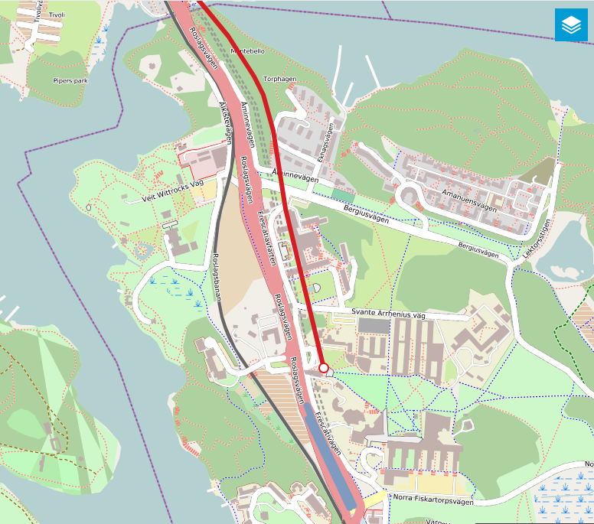

Naturhistoriska riksmuseet

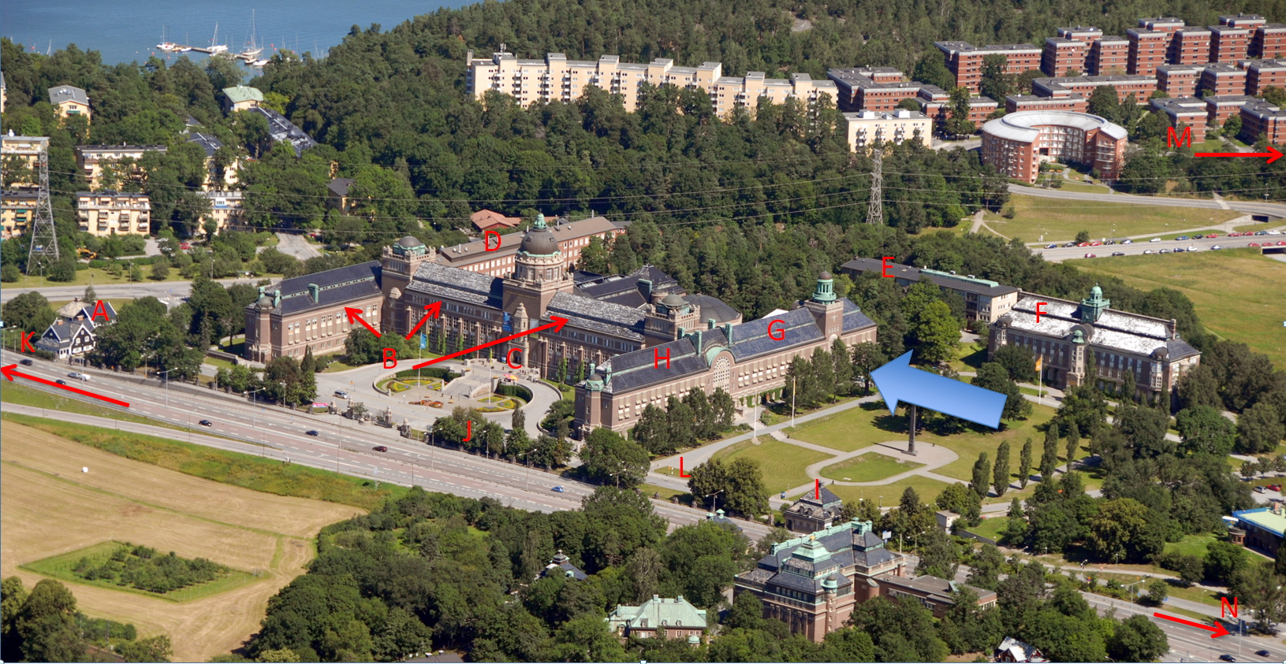

**A:** Black villa

**B:** Dept. of Zoology

**C:** Main entrance

**D:** DNA-lab

**E:** Dept. of Paleobiology, Ancient DNA-lab

**F:** Dept. of Botany

**G:** SYNTHESYS Office

**H:** Dept. of Geosciences

**I:** ‘Posthuset (guest rooms)

**J:** Bus stop #50 (down town)

**K:** ‘Matsällskapet’ or ‘Sfären’ (guest rooms) ~ 1 km

**L:** Bus stop #540 (‘Matsällskapet’)

**M:** ICA-shop (super market)/ post office, Professorsslingan 15

**N:** ‘Universitetet’ Subway

**Swedish Museum of Natural History - ARRIVAL MAP**

**From the Metro Station Universitetet,** turn left and walk approximately **300 meters to reach the museum**. Enter through the main west-facing entrance and take the stairs one floor down directly before the ticket hall (follow restaurant signs). Directly to your left at the base of the stairs, next to the restaurant, are the lecture theatres. The Workshop will be held in the small lecture theatre

**Contact at the NRM.**

Johannes Bergsten, PhD

Senior Curator/ Förste Intendent

of Coleoptera

Department of Zoology

Swedish Museum of Natural History  
Box 50007  
SE-104 05 Stockholm  
SWEDEN

Visiting address: Frescativägen 40

Phone: +46 8 5195 4192

E-mail: [johannes.bergsten@nrm.se](mailto:johannes.bergsten@nrm.se)